PHINMA UNIVERSITY OF ILOILO
College of Information Technology Education

CAPSTONE PROJECT PROPOSAL

H2Ops:Cloud-Based Operations Management System for Water Refilling Stations with Automated Sales Analytics.

In partial fulfillment for the requirements in Capstone 1 and Research Subject

MEMBERS:
PRINCE JOHN B. BUNDALAN-BSIT-3
MICHEAL JHON ANAS-BSIT-3
JOHN LLOYD CANTALLOPEZ-BSIT-3
JACINTO E. RONQUILLO JR.-BSIT-3
REYNIEL JOSH FIGEUROA ROJO-BSIT-3

SECOND SEMESTER
2025-2026

CHAPTER 1

INTRODUCTION

1.1 Background of the Study

Water refilling stations are important in supplying affordable and safe drinking water to households and businesses. High Island V is a water refilling business that operates in multiple branches in the city and province. The company provides water refilling services in three main areas. It offers purified and alkaline water refilling services, walk-in refills, door-to-door delivery, and container cleaning.

Although it has grown in terms of operations, it is still run manually in terms of controlling sales, daily orders, employee performance, and monitoring branches. The manual system increases the risk of errors and difficulties in consolidating reports from various branches.

With the development of cloud computing and automation technologies, businesses are now able to improve their operations by using digital platforms. A digital platform is a system of technologies that supports real-time monitoring, analytics, and reporting using desktop and mobile devices.

To solve these challenges, the researchers suggest H2Ops, a Responsive Cloud-based Operations Management System to centralize and automate water refilling stations. The system converts manual data into visual analytics, makes business management simpler, and eliminates manual computation.

1.2 Statement of the Problem

The study aims to develop a cloud-based operations management system that addresses the following problems:
1. How can multi-branch water refilling stations centralize sales and
operational data?
2. How can manual computation of daily sales and orders be
automated?
3. How can owners monitor real-time branch performance remotely?
4. How can the system provide clear and visual sales analytics?
5. How can data accuracy and reporting efficiency be improve?

1.3 Objectives of the Study

1.3.1 General Objective
To design and develop a cloud-based operations management system with automated sales analytics for multi-branch water refilling stations.

1.3.2 Specific Objectives

Specifically, the study aims to:

- To develop a centralized cloud database for multi-branch operations.
2. To automate daily sales and order computation.
3. To provide real-time sales monitoring and reporting.
4. To generate visual analytics such as charts and performance
Summaries.
5. To create a responsive system accessible via cloud and mobile
Devices.
6. Test and evaluate the system’s accuracy, usability, and performance.

1.4 Scope and Delimitation

Scope: The study focuses on the development of a cloud-based management system for water refilling stations that includes:

- Sales recording and automation
- Daily order tracking
- Staff performance tracking
- Sales analytics dashboard
- User access control (Admin, Branch Staff, Owner)
- Real-time analytics dashboard

Delimitations:

The system does not include water quality testing automation hardware.
The system does not include full accounting or payroll processing.
The system depends on internet connectivity.
The study is limited to the operations of High Island V water refilling enterprise.

1.5 Significance of the Study

The proposed system will benefit the following:

● Business Owners: Provides centralized monitoring, real-time
reports, and data-driven decision-making tools.
● Branch Staff: Reduces manual computation and simplifies order
recording.
● Customers: Improves service efficiency and order processing.
● Future Researchers: Serves as a reference for cloud-based
business automation systems.
1.6 Definition of Terms

● Cloud-Based System – A system hosted online and accessible via
the internet.
● Sales Analytics – Automated analysis of sales data to generate
insights and visual reports.
● Multi-Branch Monitoring – Centralized tracking of operations across
different locations.
● Dashboard – A visual interface showing real-time summaries and
charts.
● Automation – The use of technology to perform tasks without manual
computation.
● Administrator – A user responsible for system supervision and
moderation.
● User Behavior Monitoring – Tracking and analyzing user actions to
ensure safety and compliance.

CHAPTER 2

REVIEW OF RELATED LITERATURE AND STUDIES

2.1 Foreign Studies

A study by Singh and Wajgi (2016) titled “Data Analysis and Visualization of Sales Data”, presented at the World Conference on Futuristic Trends in Research and Innovation for Social Welfare, discussed the challenges of handling large volumes of sales data generated by businesses. The researchers emphasized that with the rapid growth of data from various sources, analyzing and interpreting information becomes difficult without proper tools. They highlighted that traditional methods are not sufficient to process and visualize large datasets efficiently. As a solution, the study proposed a system that focuses on data analysis and visualization to help users better understand sales performance, support decision-making, and improve business operations.

2.2 Local Studies

‎A study conducted by Espinosa, Maambong, Taylaran, Bagongon, Formentera, and Jadraque (2022) titled “Information Systems Development and Technology Plan for Water Refilling Station”, examined the operational challenges faced by the NADAP water refilling station. The researchers found that manual transaction recording significantly affected the efficiency of the business, leading to poor performance and difficulty in managing daily operations. The study also highlighted that the absence of proper information systems and IT infrastructure limits the ability of businesses to achieve both short-term and long-term goals. Through surveys and analysis of business processes, the researchers identified Cloud Computing, transaction processing and inventory management as key areas needing improvement.

2.3 Related Literature
According to Sean Marston, Zhi Li, Subhajyoti Bandyopadhyay, Juheng Zhang, and Anand Ghalsasi (2011) in their article Cloud Computing—The Business Perspective published in the journal Decision Support Systems, cloud computing has become one of the most important developments in modern computing. The authors explain that cloud technology allows businesses to store, manage, and process data through internet-based platforms instead of depending on local hardware systems. Their study also highlights how cloud computing helps organizations improve operational efficiency, accessibility, and scalability while lowering infrastructure costs.

2.4 Synthesis of the Reviewed Literature
‎ 2.4 Synthesis of the Reviewed Literature ‎The reviewed foreign and local studies demonstrate that both studies suggest that businesses require automated systems to manage data effectively and improve operational efficiency. The local study highlights the need for system implementation in water refilling stations, while the foreign study emphasizes the value of transforming data into meaningful insights through visualization. In relation to these findings, the proposed H2Ops integrates both concepts by automating transaction processes and providing real-time sales analytics through a cloud-based platform. This allows business owners to monitor operations efficiently, reduce manual errors, and make informed decisions based on accurate and visualized data.

CHAPTER 3

METHODOLOGY

3.1 Research Design

‎The study will use a Developmental Research Design focusing on system design and software development.

3.2 System Development Methodology

The Agile Development Model will be used, consisting of the following phases:

1. Planning
2. Analysis
‎ 3. Design
4. ‎ Development‎
5. Testing
‎ 6. Deployment

3.3 System Architecture
The system will follow a client-server architecture which allows the client and server to communicate through the system. The client will interact through the system interface, and the server will handle data processes and manage databases.

3.4 Tools and Technologies Used

● Frontend: HTML, CSS, JavaScript, Jinja2
● Backend: Python/Flask
● Machine Learning: Python (Scikit-learn)
● Database: MySQL
● Development Tools: Visual Studio Code

3.5 Data Gathering Techniques
- Interview
● Surveys
● Document analysis

3.6 Testing Procedures
- Unit Testing - Test individual modules such as login and payment recording.
- System Testing - Ensure integrated modules work correctly.
- User Acceptance Testing - Verify the system meets operational requirements.
3.7 Evaluation Criteria
The system will be evaluated based on the following criteria:
● Functionality
● Usability
● Reliability
● Security
● Efficiency
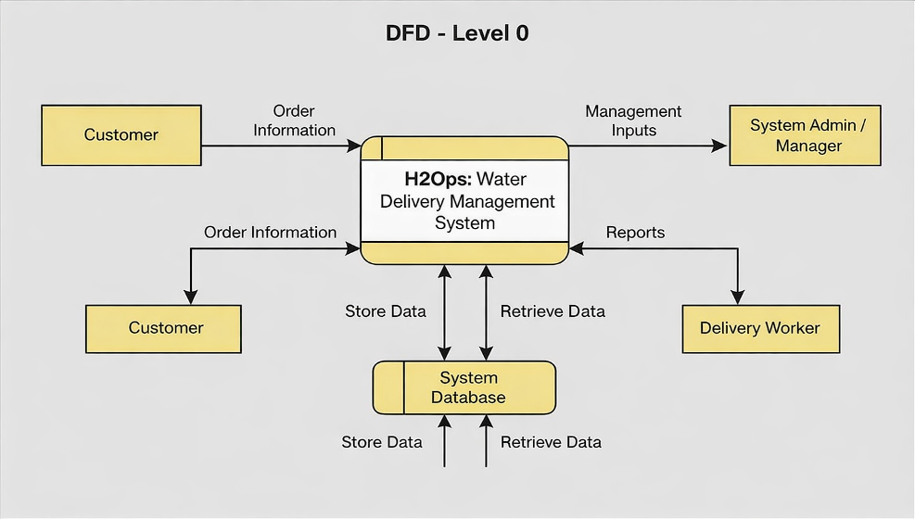
Supporting Diagram

- Customers submit order information for water delivery requests
- System Admin / Manager provides management inputs such as configurations and updates
- Delivery Workers receive delivery details and reports to fulfill assigned tasks
- The system processes all interactions between customers, admin, and delivery workers
- Data is stored and retrieved from the system database for operations, reporting, and tracking
Entity Relationship Diagram (ERD)
Entities:
● Customer (CustomerID, Name, Address, PhoneNumber, Email)
● Order (OrderID, CustomerID, Location)
● Staff (Staff_ID, Name, PhoneNumber)
● Admin (AdminID, Email, Password)

Relationships:
● Customer places Order
● Order is assigned to Admin and staff
● Staff delivers Order
● Admin manages DeliveryWorker

Use Case Diagram
Actors:
● Customer
● Admin
● Delivery Worker

Use Cases:

Customer:
● Register Account
● Login
● Place Order
● View Order Status
● Update Profile

Admin:
● Login
● Manage Customers
● Manage Orders
● Assign Orders to Delivery Worker
● Monitor System

Staff:
● Login
● View Assigned Orders
● Update Delivery Status
● Contact Customer

References
Singh, A., & Wajgi, R. (2016). Data analysis and visualization of sales data. Paper presented at the World Conference on Futuristic Trends in Research and Innovation for Social Welfare.

Marston, S., Li, Z., Bandyopadhyay, S., Zhang, J., & Ghalsasi, A. (2011). Cloud computing—The business perspective. Decision Support Systems, 51(1), 176–189.

Espinosa, R., Maambong, J., Taylaran, J., Bagongon, M., Formentera, L., & Jadraque, K. (2022). Information systems development and technology plan for water refilling station.

